B V V SESHADRI AKULA
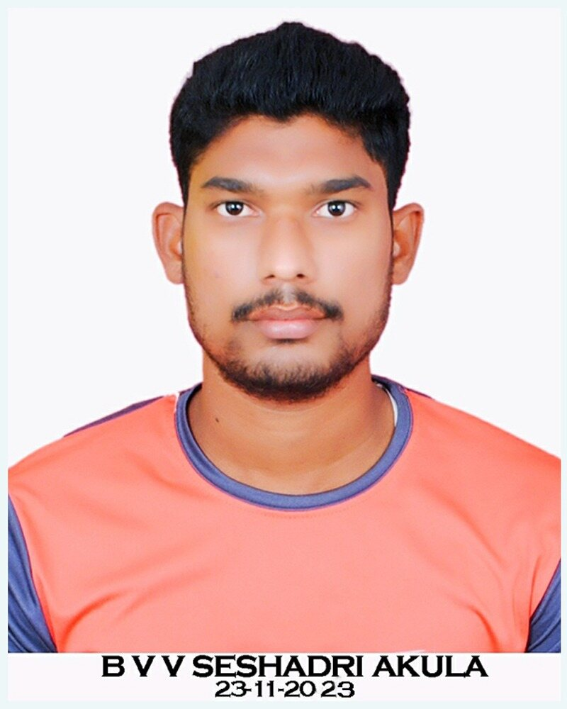
2-101, Kakinada mandal
Main road, opp: SBI
Thimmapuram-533005
Andhra Pradesh, INDIA
Email: seshadriakula@gmail.com
Mobile No: 7659048132
Degree/Class | Institution/University | Year
MA HISTORY | Central University of Hyderabad,(UOH) Telangana. | 2019-2021
BA HEP | Economics, Political Science & History  PR Govt Degree college Kakinada | 2016-2019
INTERMEDIATE | HEG (History, Economics, Geography) Jawahar Navodaya Vidyalaya,(JNV) Peddapuram | 2014-2016
S.S.C | Jawahar Navodaya Vidyalaya,(JNV) Peddapuram | 2014

Career Objective
To contribute as a team member in a challenging work environment by aligning my adaptable and friendly nature to create a lively ambience that is healthy for all to work and grow.
Academic Profile

EXTRA QUALIFICATIONS
QUALIFIED IN: -APSET (slet). 2022
QUALIFIED IN: - UGC NET (asst professor) 2024.

WORKING AREAS
Operating various kinds of Software's, Accounting Packages & MS-Office, power point presentation

WORK PROFILE AND FINANCIAL STATEMENT
- ► Worked as Lecturer in History, Guest faculty in PR Govt College, Kakinada, AP. from November 2022 to January 2024. (15 months)
Personal Traits
- Ability to work as a team player and lead Teams
- Good oral and written communication skills in English, Telugu & Hindi
- Networking, Listening to Music, Love to Learn New Things
- Positive Attitude and willing to take Responsibility.
Personal Information:
Name. : B V V SESHADRI AKULA
Father's Name. : Sri. Akula Bulli raju
Date of Birth. : 15th August 1998
Marital Status. : Unmarried
Mother Tongue. : Telugu
Languages known. : Telugu, English & Hindi.
Hobbies. : Travelling, Book reading, and Gardening.
Strengths. : Hard work, Sincerity, Punctuality and Patience.
Work Motto. : Actions speak better than words.

Declaration:
I hereby declare that the information mentioned above is true to the best of my knowledge and I bear the responsibility of its correctness.

Place: KAKINADA
Date: 02-07-2025. (B V V SESHADRI AKULA)

